WANDORA
PA4 Test Report
Execution evidence for UC01 and UC02

Document | Value
Project | Wandora - collaborative trip planning application
Course deliverable | PA4 - Testing
Team | Group 11
Version | 1.0
Prepared date | 14 August 2026

1. Executive Summary
The PA4 execution scope covered the two implemented main workflows: UC01 Trip Creation and Preference Input, and UC02 AI Itinerary Generator. The isolated backend suite completed successfully with 13 passing checks. Ten traced functional cases for UC01 and UC02 are reported as passed based on that suite and direct browser validation evidence.
Metric | Result
Executed functional cases in PA4 scope | 10
Passed | 10
Failed | 0
Blocked | 0 functional cases; Selenium driver setup is an environment limitation
Automated backend suite | 13 passed, 33 warnings, 1.02s

2. Environment and Execution Method
Item | Actual environment
Date | 14 August 2026
Device / OS | Windows 11 desktop
Browser | Codex in-app Chromium browser, authenticated user session
Frontend / backend | http://127.0.0.1:5173 / http://127.0.0.1:8000
Automated execution | Python 3.12.13, pytest 9.1.1, SQLite in-memory isolation
Command | .venv\Scripts\python.exe -m pytest tests\backend -q --disable-warnings --tb=short

The project also contains a Selenium browser E2E suite. Its execution was attempted, but Selenium Manager could not obtain ChromeDriver because the environment could not reach the Chrome for Testing version feed. This is recorded as test-environment infrastructure, not a product defect. Direct browser checks were completed through the in-app browser session.

3. Detailed Test Results
ID | Test case | Evidence | Status
TC_UC01_01 | Valid trip payload accepted | Backend schema check | Passed
TC_UC01_02 | Missing destination is rejected | Backend schema + browser validation | Passed
TC_UC01_03 | Missing dates are blocked in wizard | Direct browser validation | Passed
TC_UC01_04 | End date before start date is rejected | Backend schema check | Passed
TC_UC01_05 | Group size below one is rejected | Backend schema check | Passed
TC_UC02_01 | Fallback generation creates itinerary days | AI service check | Passed
TC_UC02_02 | Generated activities include a title and schedule | AI service check | Passed
TC_UC02_03 | Preview remains unsaved before acceptance | Itinerary service check | Passed
TC_UC02_04 | Accepted draft persists as itinerary | Itinerary service check | Passed
TC_UC02_05 | Regeneration preserves manual activity and version restore | Itinerary service check | Passed

4. Defects and Observations
ID | Type | Severity | Description and action
OBS-01 | Environment | Low | Selenium browser E2E cannot start because ChromeDriver download is blocked. Use a pre-installed matching driver or allow the version-feed request before the next run.
OBS-02 | Quality | Low | The backend suite emits deprecation warnings for datetime.utcnow. No functional behaviour failed; schedule migration to timezone-aware UTC calls.

No functional product defect was found in the executed UC01/UC02 scope.

5. Testing Session Evidence
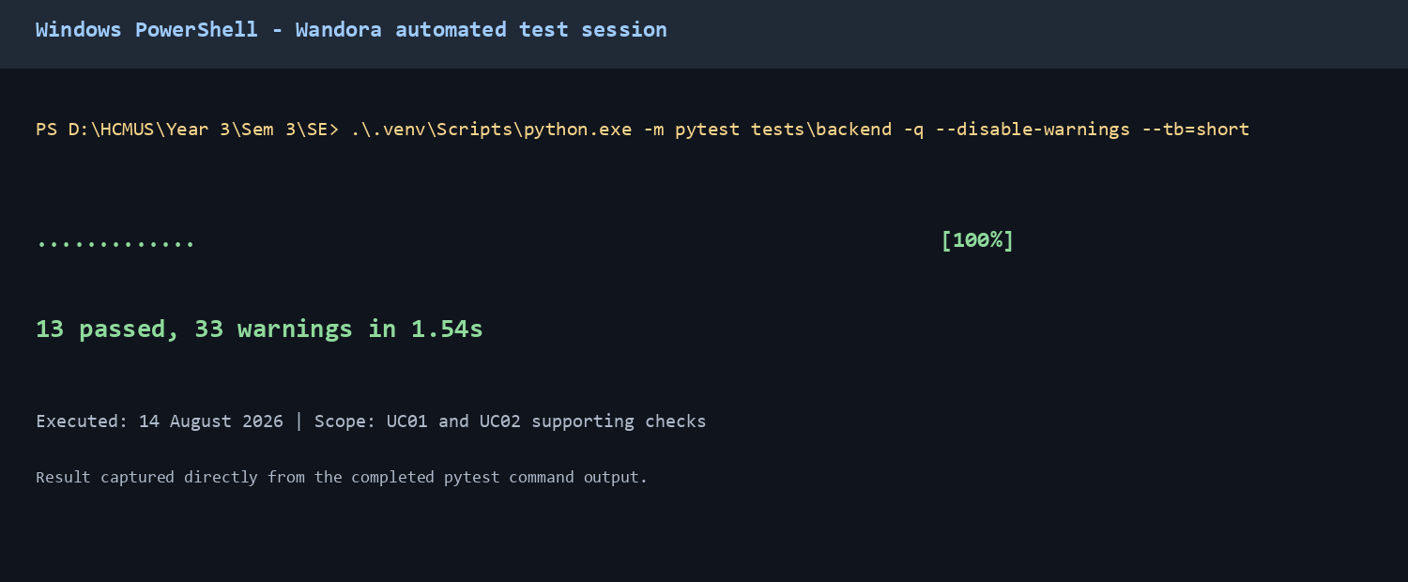
Figure 1. Automated pytest session for the backend checks; actual output: 13 passed.

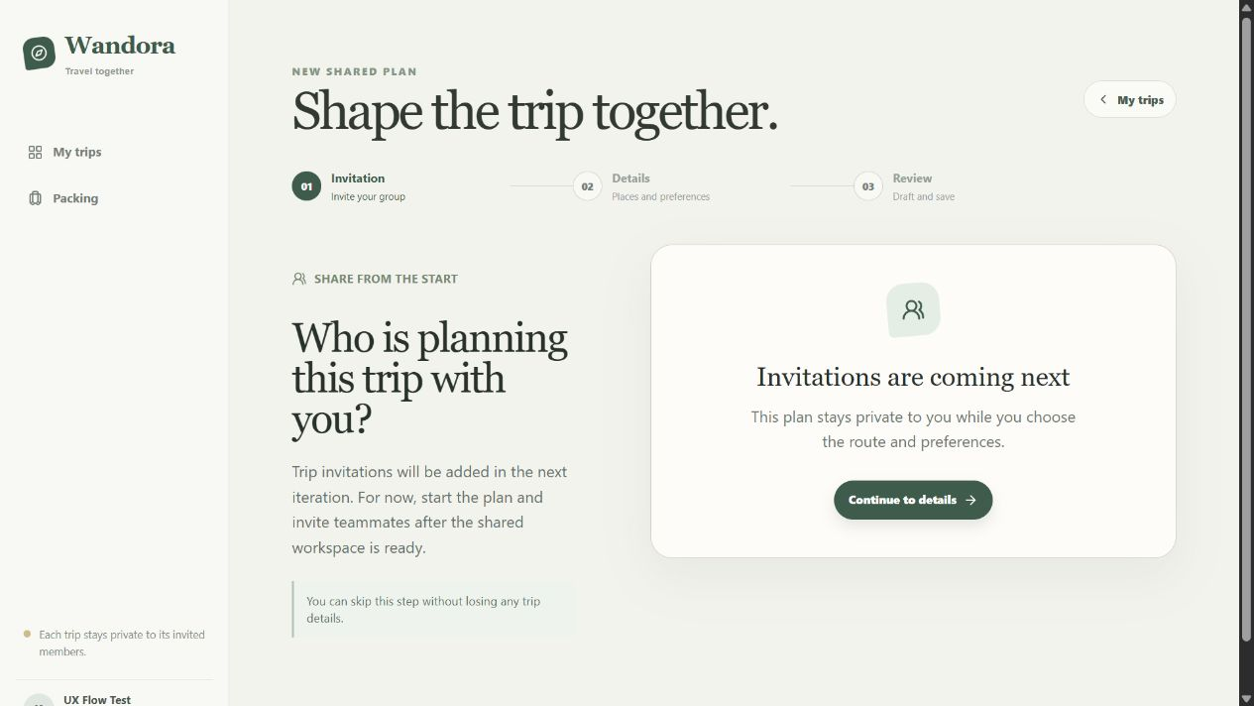
Figure 2. UC01 trip-creation workflow with the full workspace sidebar visible.

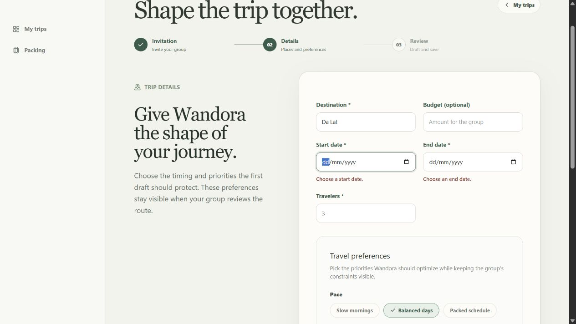
Figure 3. UC01 validation state showing required date feedback in the trip details form.

6. Conclusion
UC01 and UC02 meet the executed PA4 functional checks. The current test evidence supports trip creation validation and deterministic itinerary generation, review, save, regeneration, and restoration behaviour. Before a broader release test cycle, repair the Selenium driver setup and execute the retained browser E2E suite across the target browsers.

